CSC500 Module 1: Critical Thinking Assignment

Part 1 - Addition and Subtraction of Numbers with Input Validation
Pseudocode
BEGIN
IMPORT Decimal and InvalidOperation
VALIDATE FIRST NUMBER
LOOP until valid input is entered
PROMPT user to enter valid first number (Positive or Negative)
REMOVE leading/trailing spaces (using strip())
IF input is empty THEN
DISPLAY "Input value cannot be empty!! Please enter a valid number either positive or negative."
CONTINUE loop
ENDIF
TRY
CONVERT input to Decimal
STORE as number1
EXIT loop
CATCH InvalidOperation
DISPLAY "Invalid Input!! Please enter only numerical values either positive or negative."
ENDTRY
ENDLOOP
VALIDATE SECOND NUMBER
LOOP until valid input is entered
PROMPT user to enter second number (Positive or Negative)
REMOVE leading/trailing spaces (using strip())
IF input is empty THEN
DISPLAY "Input value cannot be empty!! Please enter a valid number either positive or negative."
CONTINUE loop
ENDIF
TRY
CONVERT input to Decimal
STORE as number2
EXIT loop
CATCH InvalidOperation
DISPLAY "Invalid Input!! Please enter only numerical values either positive or negative."
ENDTRY
ENDLOOP
PERFORM Arithmetic OPERATIONS
SET addition = number1 + number2
SET subtraction = number1 - number2
DISPLAY RESULTS
DISPLAY addition result
DISPLAY subtraction result
END

Note: I have used Decimal class (numeric data type) from python’s decimal module instead of ‘Float’ datatype to avoid Decimal-point precision issues and to get accurate arithmetic operations results.

Source Code
""""
Assignment 1 - Part 1
Arithmetic operations - Addition and Subtraction with input validations
Author: Shadab
"""
# Python code for Addition and Subtraction of numbers
# user provides Inputs at Runtime and also added inputted Value validations
from decimal import Decimal, InvalidOperation
# Validating First Number
while True:
try:
number1 = input("Enter Valid First Number (Positive or Negative): ").strip()
# Checking if the provided input is empty and asking user to input valid values
if number1 == "":
print("Input value cannot be empty!! Please enter a valid number either positive or negative.\n")
continue
number1 = Decimal(number1)
break
except InvalidOperation:
print("Invalid Input!! Please enter only numerical values either positive or negative.\n")
# Validating Second Number and Second Number input is asked only if the first number is valid
while True:
try:
number2 = input("Enter Valid Second Number (Positive or Negative): ").strip()
# Checking if the provided input is empty and asking user to input valid values
if number2 == "":
print("Input value cannot be empty!! Please enter a valid number either positive or negative.\n")
continue
number2 = Decimal(number2)
break
except InvalidOperation:
print("Invalid Input!! Please enter only numerical values either positive or negative.\n")
# Arithmetic Operations
addition = number1 + number2
subtraction = number1 - number2
print("\n***** Result Summary *****\n")
print("Result for Addition of Numbers:", addition)
print("Result for subtraction of Numbers:", subtraction)

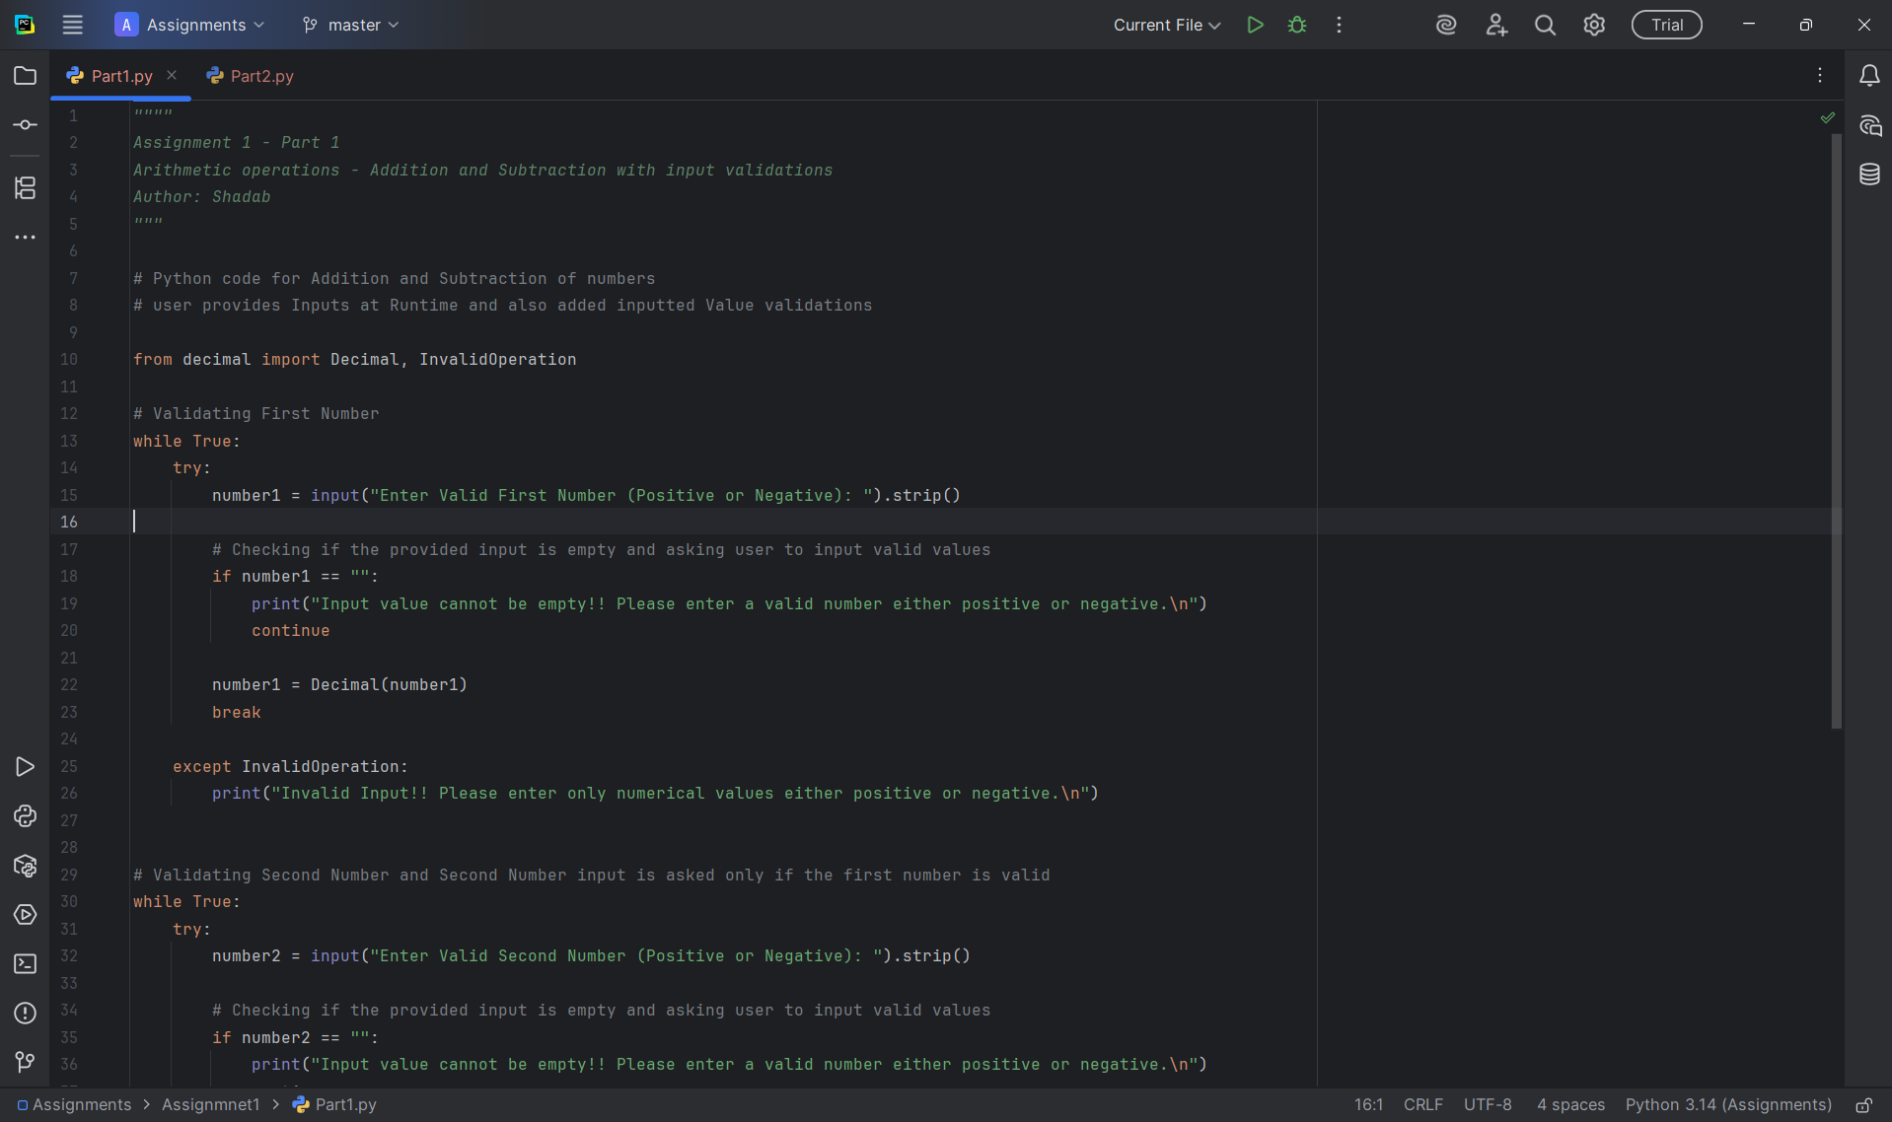

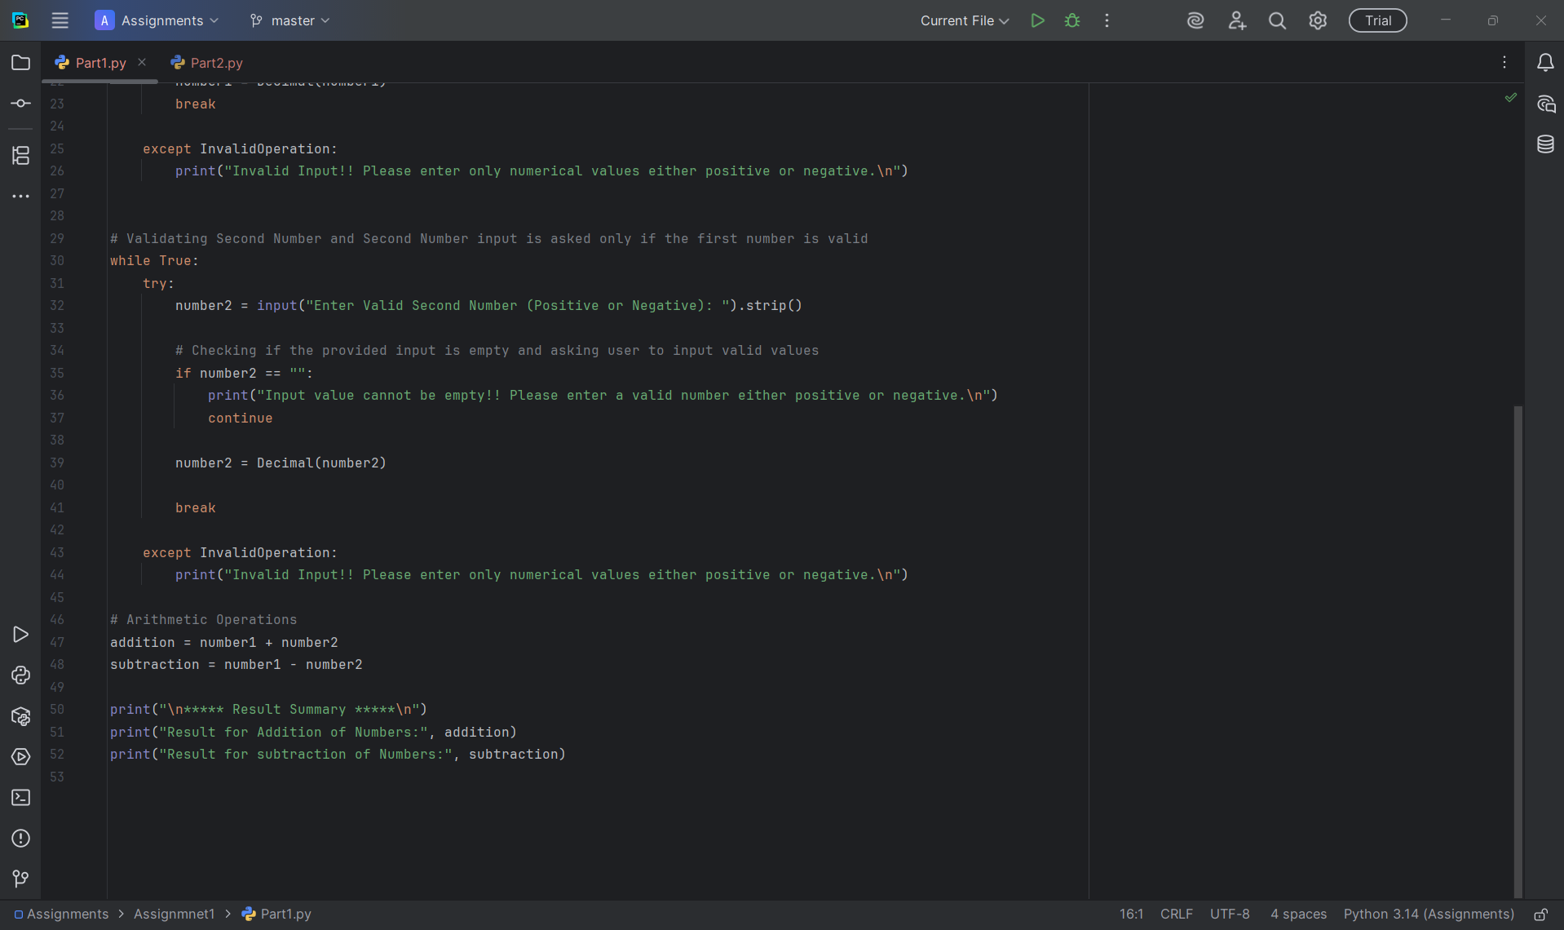

Program Execution Screenshots
Validation 1: When input is empty for first number
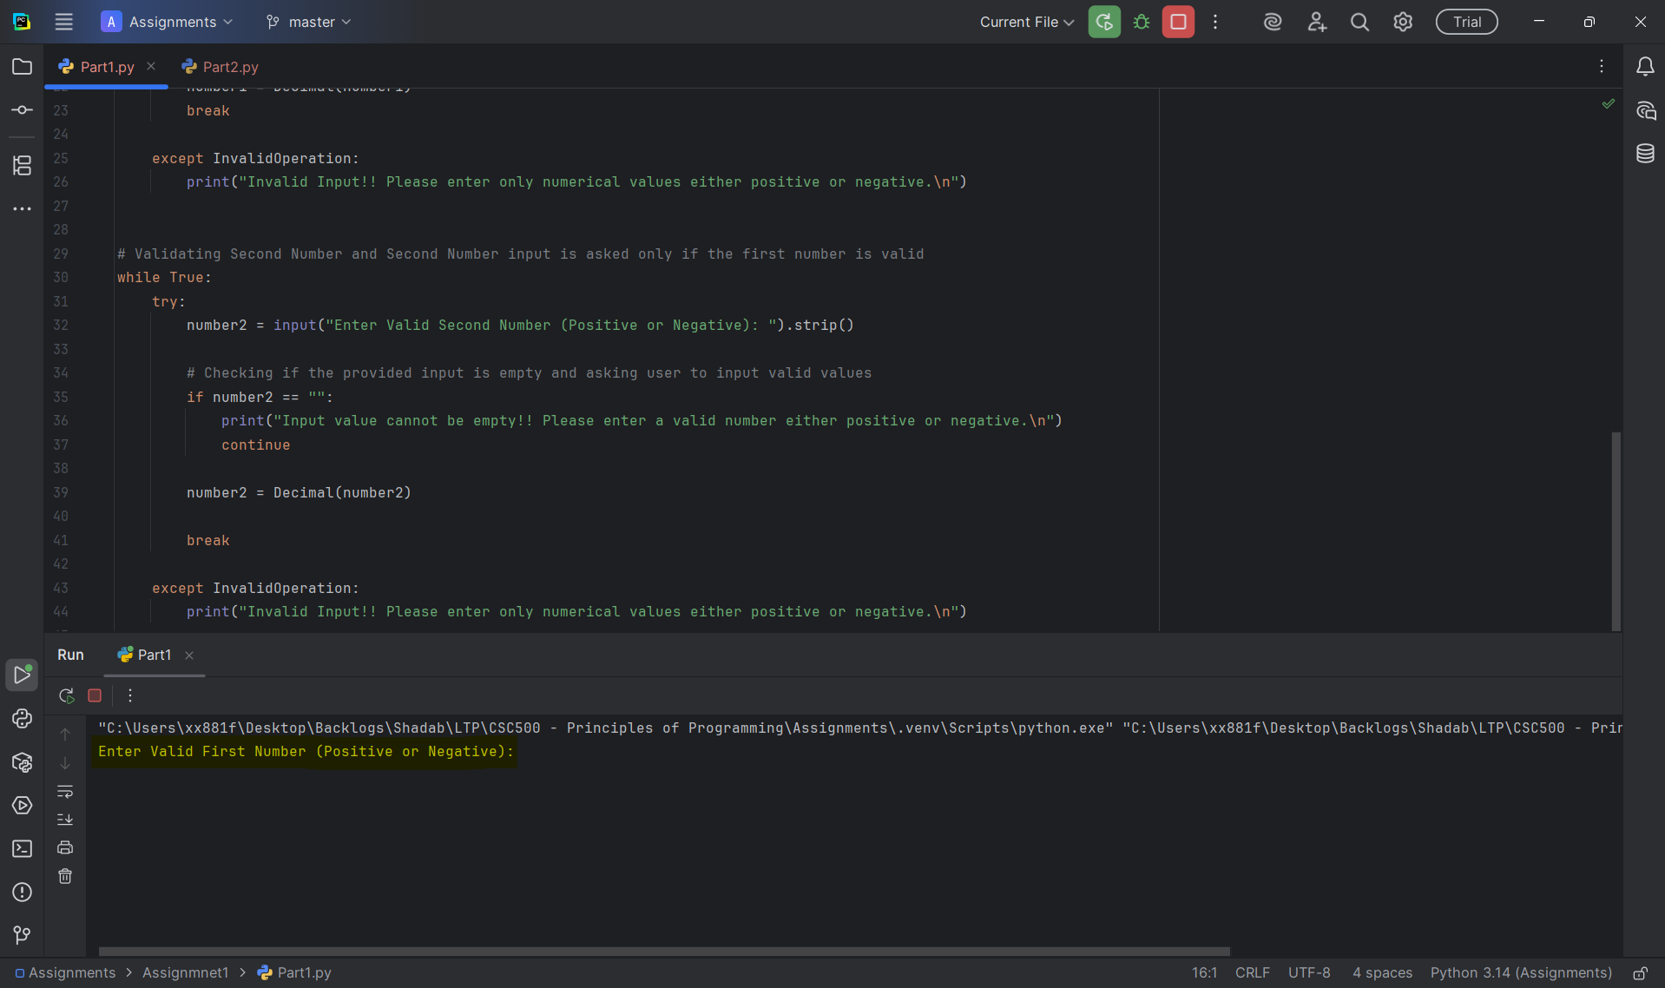

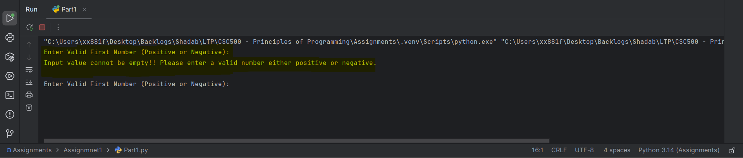

Validation 2: When input for first number is strings
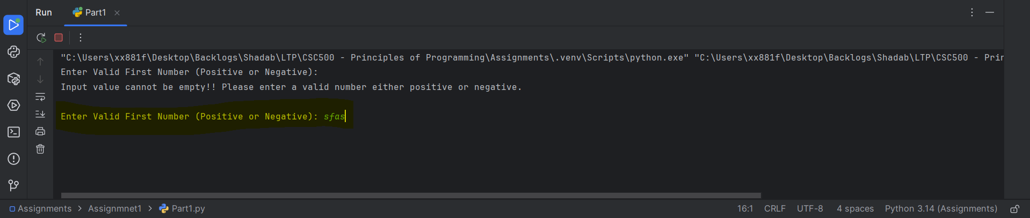

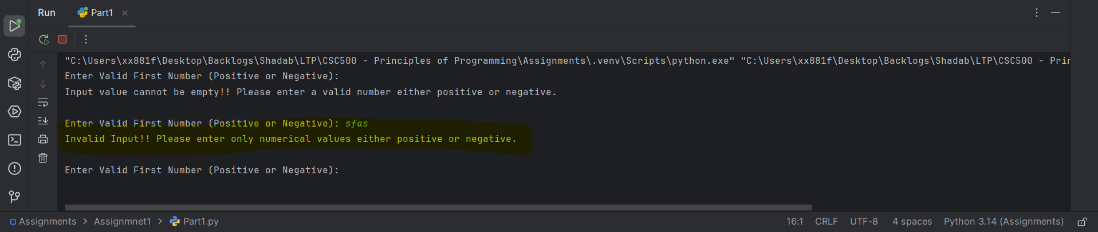

Validation 3: When first number is provided with valid value and second number is empty, validation message should be shown and should ask to re-enter second number
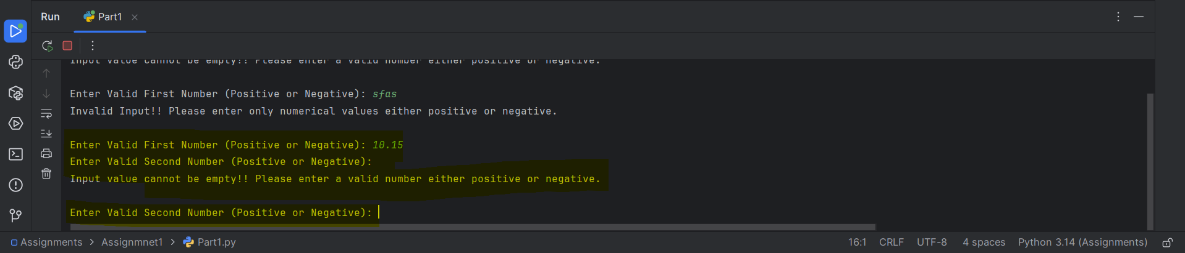

Validation 4: When first number is provided with valid value and second number is inputted string value, validation message should be shown and should ask to re-enter second number
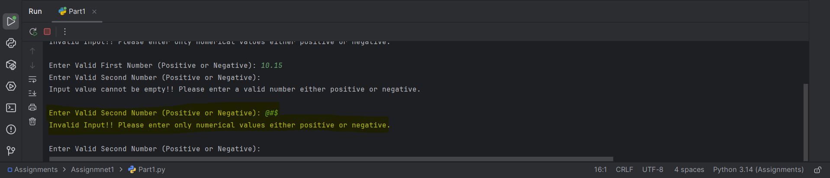

Validation 5: Valid inputs for both numbers
Number 1 = 10.15
Number 2 = -5.215
Addition = 4.935
Subtraction = 15.365
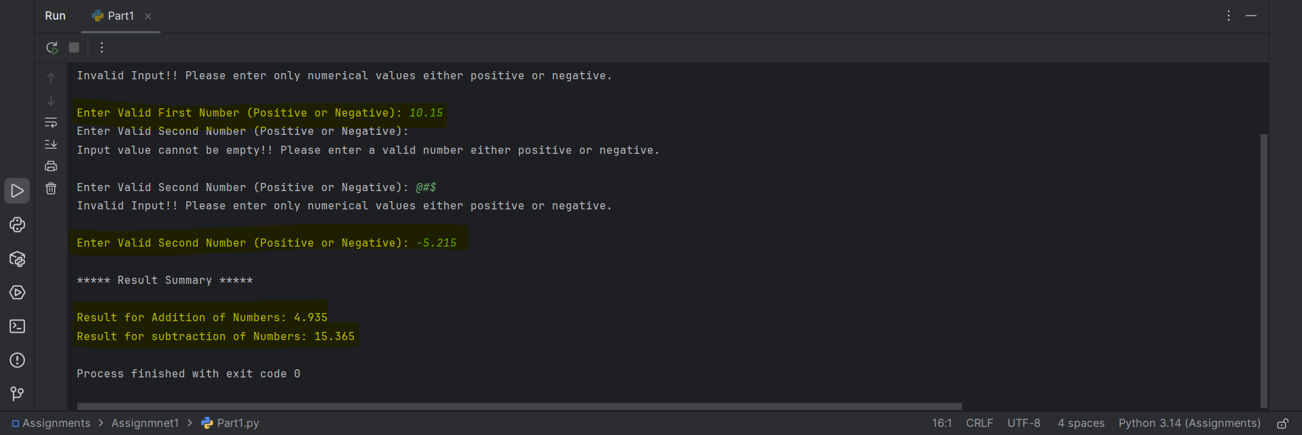

Part 2 - Multiplication and Division of Numbers with Input Validation
Pseudocode
BEGIN
IMPORT Decimal and InvalidOperation
VALIDATE FIRST NUMBER
LOOP until valid input is entered
PROMPT user to enter first number (Positive or Negative)
REMOVE leading/trailing spaces (using strip())
IF input is empty THEN
DISPLAY "Input value cannot be empty!! Please enter a valid number either positive or negative."
CONTINUE loop
ENDIF
TRY
CONVERT input to Decimal
STORE as number1
EXIT loop
CATCH InvalidOperation
DISPLAY "Invalid Input!! Please enter only numerical values either positive or negative."
ENDTRY
ENDLOOP
VALIDATE SECOND NUMBER
LOOP until valid input is entered
PROMPT user to enter second number (Positive or Negative)
REMOVE leading/trailing spaces (using strip())
IF input is empty THEN
DISPLAY "Input value cannot be empty!! Please enter a valid number either positive or negative."
CONTINUE loop
ENDIF
TRY
CONVERT input to Decimal
STORE as number2
IF number2 equals 0 THEN
DISPLAY "Division by Zero provides a Undefined value. Enter a Non-Zero value"
CONTINUE loop
ENDIF
EXIT loop
CATCH InvalidOperation
DISPLAY "Invalid Input!! Please enter only numerical values either positive or negative."
ENDTRY
ENDLOOP
PERFORM OPERATIONS
SET multiplication = number1 × number2
SET division = number1 ÷ number2
DISPLAY RESULTS
DISPLAY multiplication result
DISPLAY division result
END

Source Code
""""
Assignment 1 - Part 2
Arithmetic operations - Multiplication and Division with input validations
Author: Shadab
"""
# Python code for Multiplication and Division of numbers
# user provides Inputs at Runtime and also added inputted Value validations
from decimal import Decimal, InvalidOperation
# Validating First Number
while True:
try:
number1 = input("Enter Valid First Number (Positive or Negative): ").strip()
# Checking if the provided input is empty and asking user to input valid values
if number1 == "":
print("Input value cannot be empty!! Please enter a valid number either positive or negative.\n")
continue
number1 = Decimal(number1)
break
except InvalidOperation:
print("Invalid Input!! Please enter only numerical values either positive or negative.\n")
# Validating Second Number and Second Number input is asked only if the first number is valid
while True:
try:
number2 = input("Enter Valid Second Number (Positive or Negative): ").strip()
# Checking if the provided input is empty and asking user to input valid values
if number2 == "":
print("Input value cannot be empty!! Please enter a valid number either positive or negative.\n")
continue
number2 = Decimal(number2)
# To prevent Division by Zero
if number2 == 0:
print("Division by Zero provides a Undefined value. Enter a Non-Zero value\n")
continue
break
except InvalidOperation:
print("Invalid Input!! Please enter only numerical values either positive or negative.\n")
# Arithmetic Operations
addition = number1 * number2
subtraction = number1 / number2
print("\n***** Result Summary *****\n")
print("Result for Multiplication of Numbers:", addition)
print("Result for Division of Numbers:", subtraction)
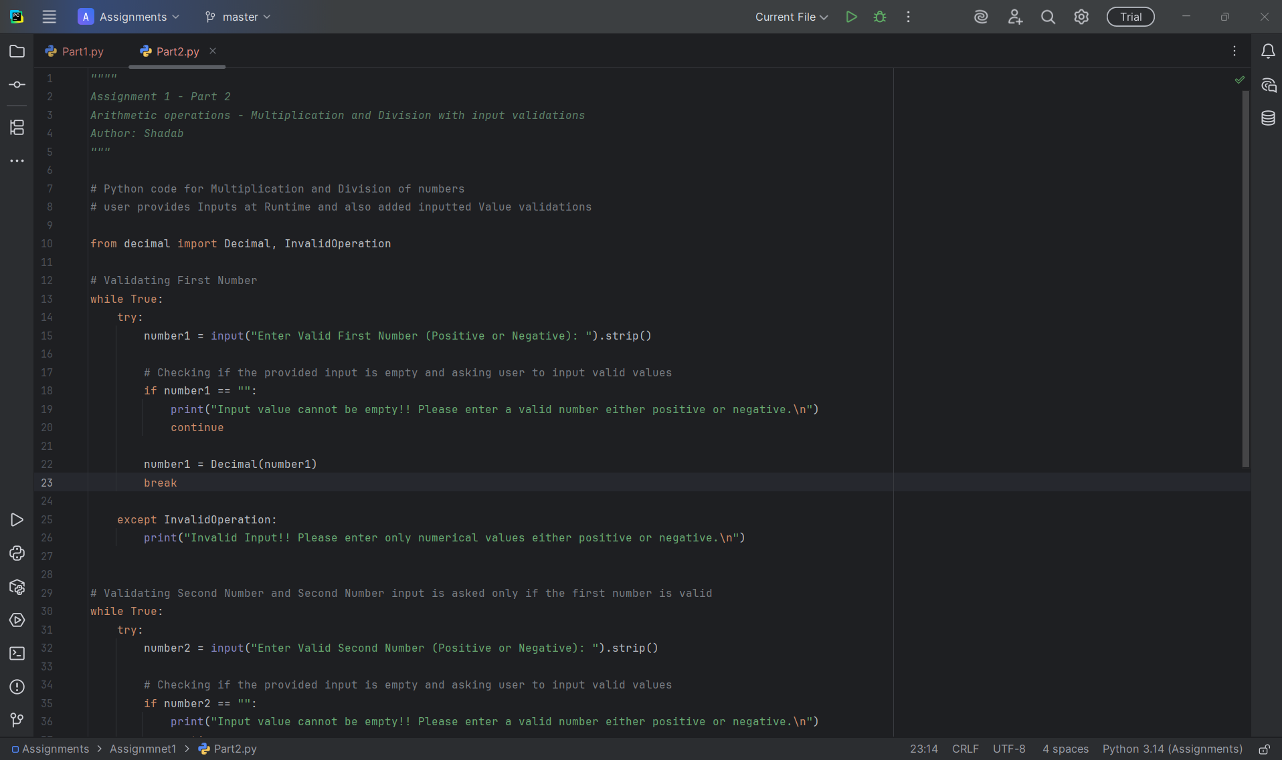

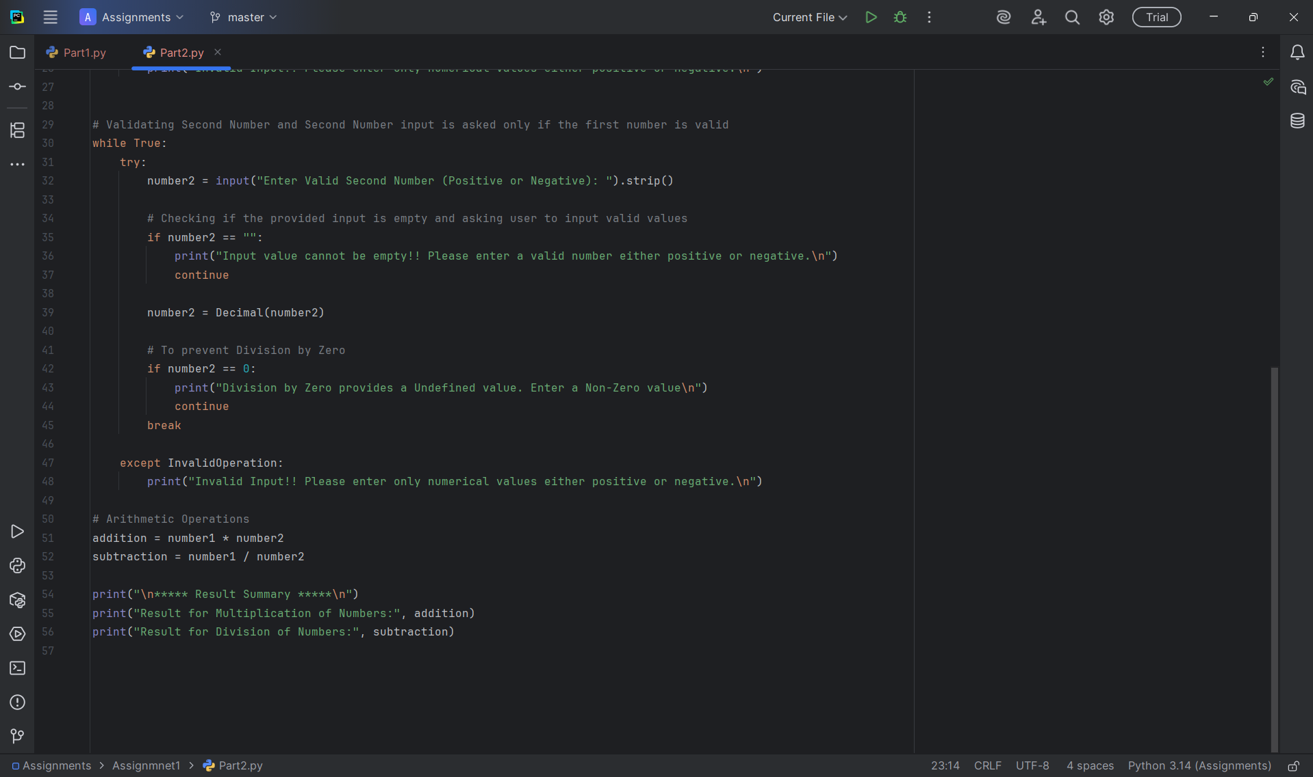

Program Execution Screenshots
Validation 1: When input is empty for first number
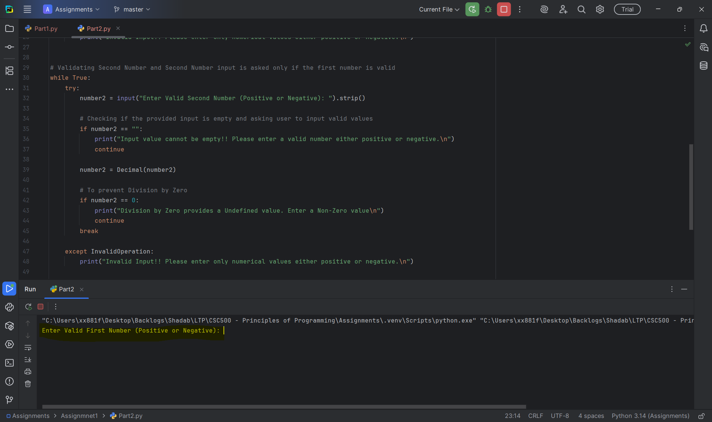

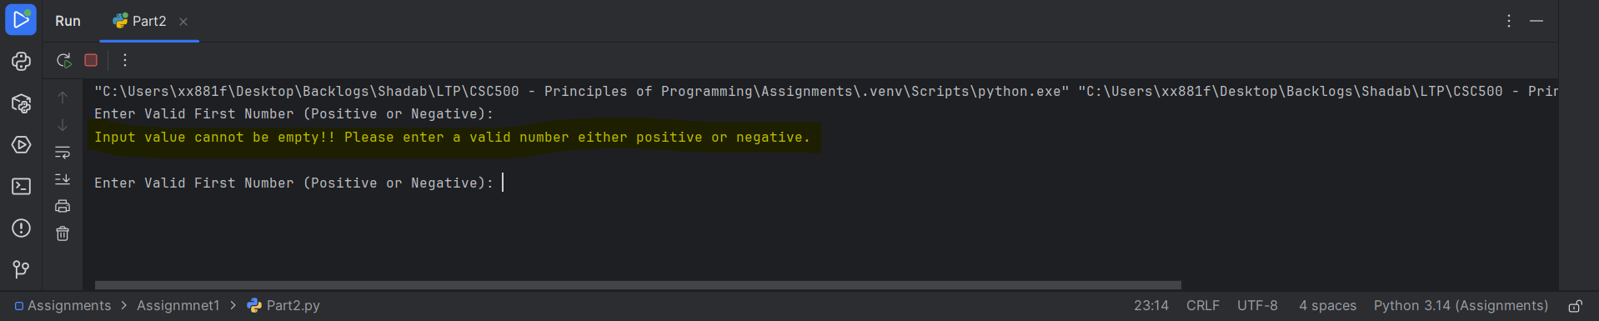

Validation 2: When input for first number is strings
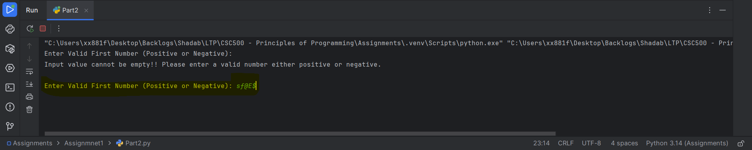

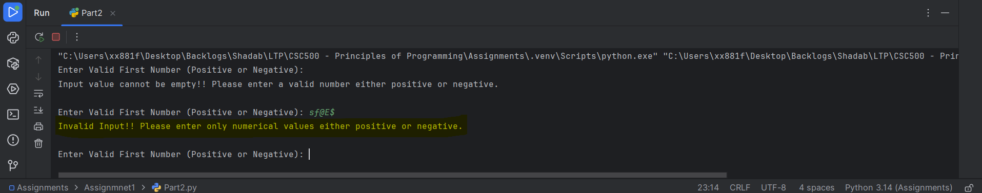

Validation 3: When first number is provided with valid value and second number is empty, validation message should be shown and should ask to re-enter second number
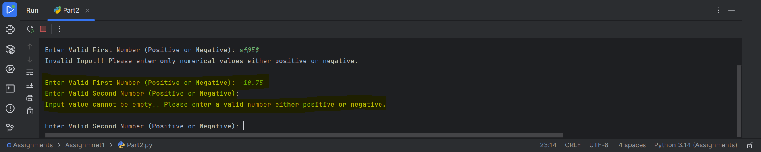

Validation 4: When first number is provided with valid value and second number is inputted string value, validation message should be shown and should ask to re-enter second number
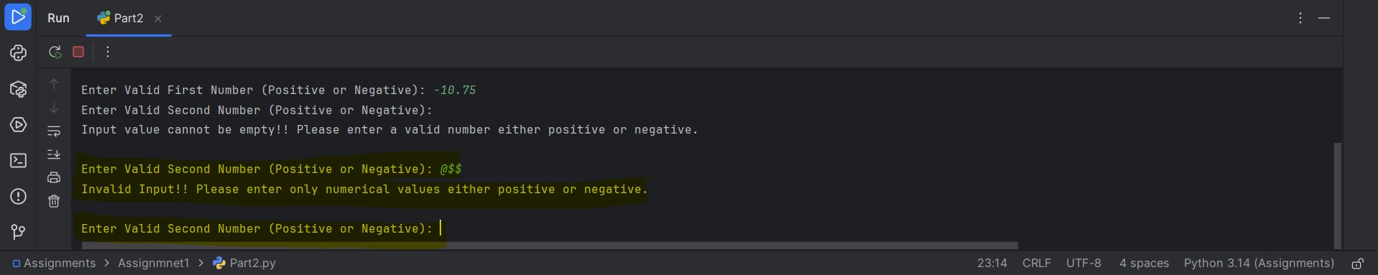

Validation 5: Valid inputs for both numbers
Number 1 = -10.75
Number 2 = 2.5
Multiplication = -26.875
Division = -4.3
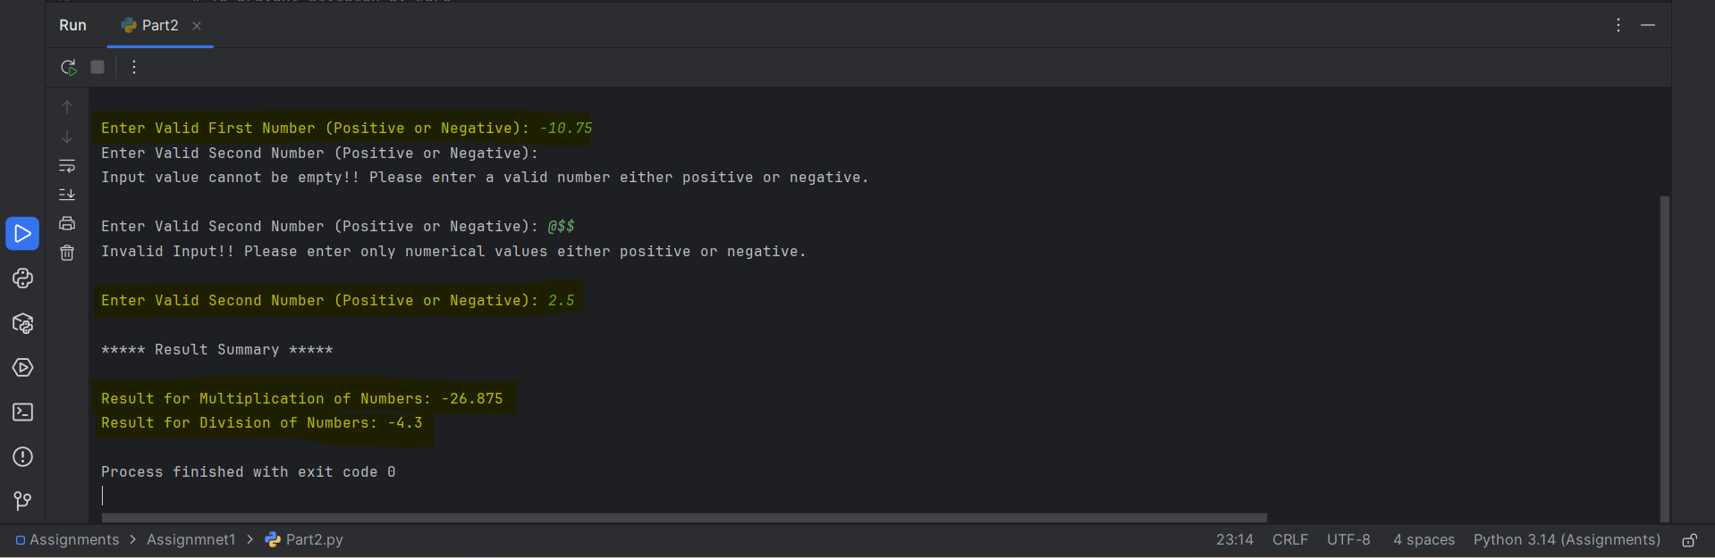

Part 3 – Git Repository
Created a Git-Hub Account with Repository name as “CSC500---Principles-of-Programming”
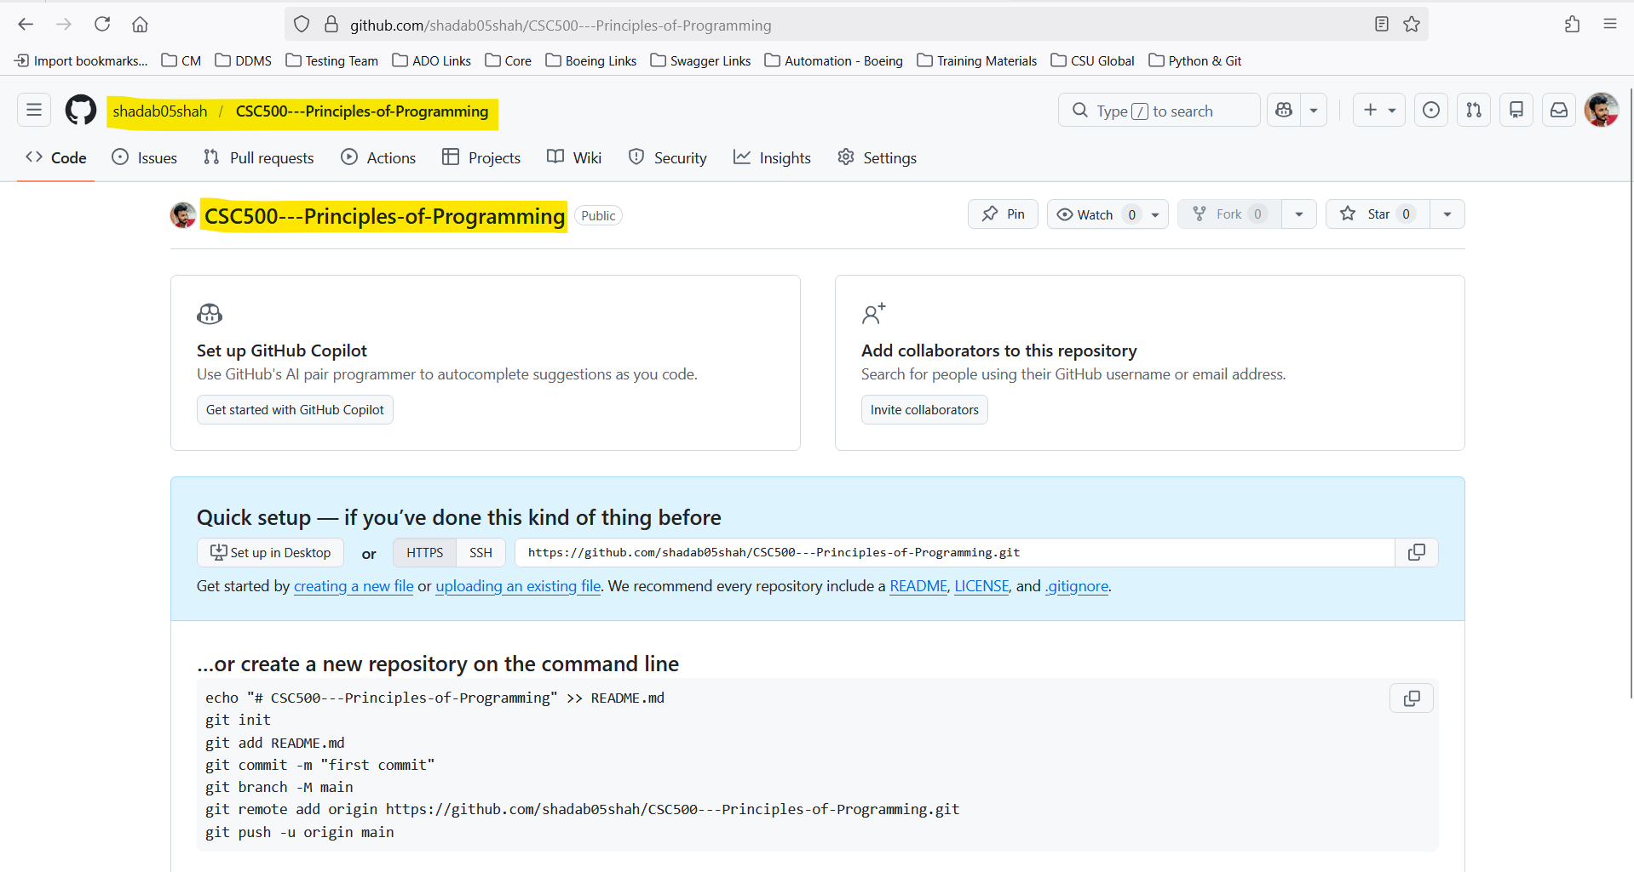

Main Project Folder Structure in Local
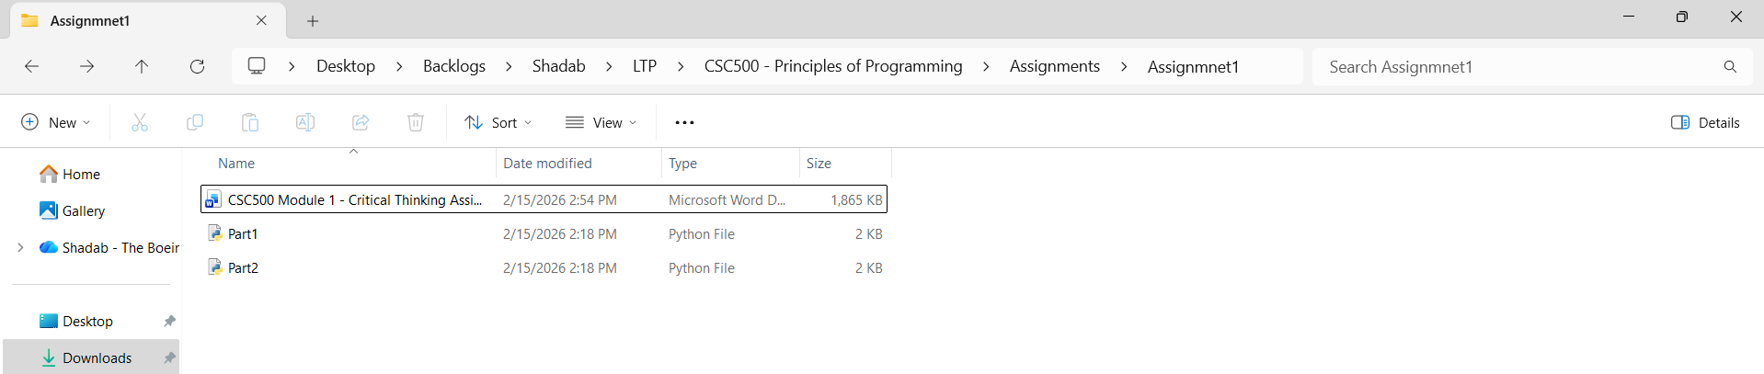

Initialize Git using “git init”
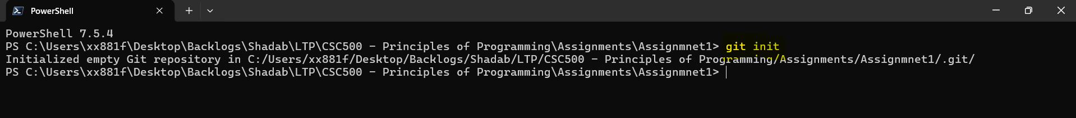

Add Files using “git add .”
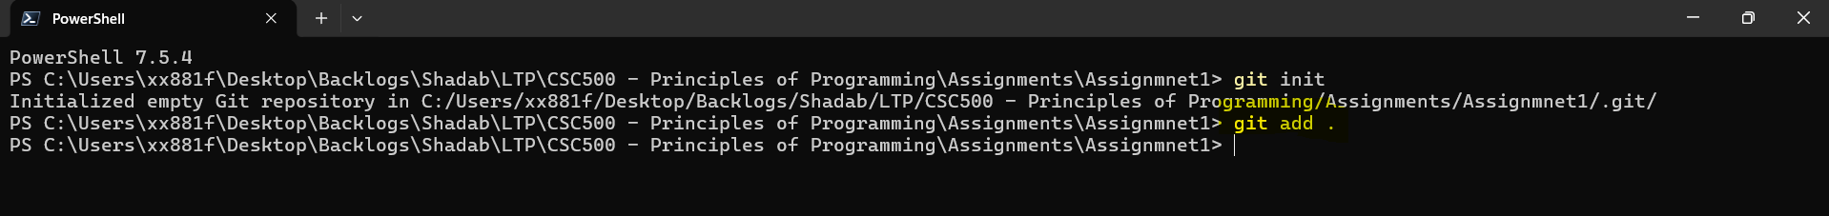

Commit Files using “git commit -m “Added assignment for part1 and part2””
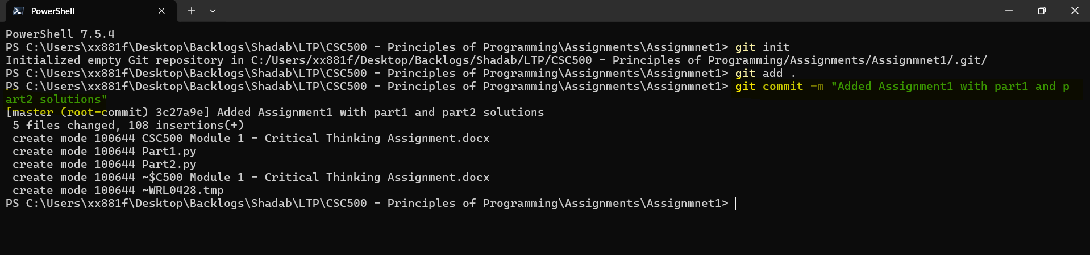

Connecting to Git-Hub using the repository link created in browser “git remote add origin https://github.com/shadab05shah/CSC500---Principles-of-Programming.git”
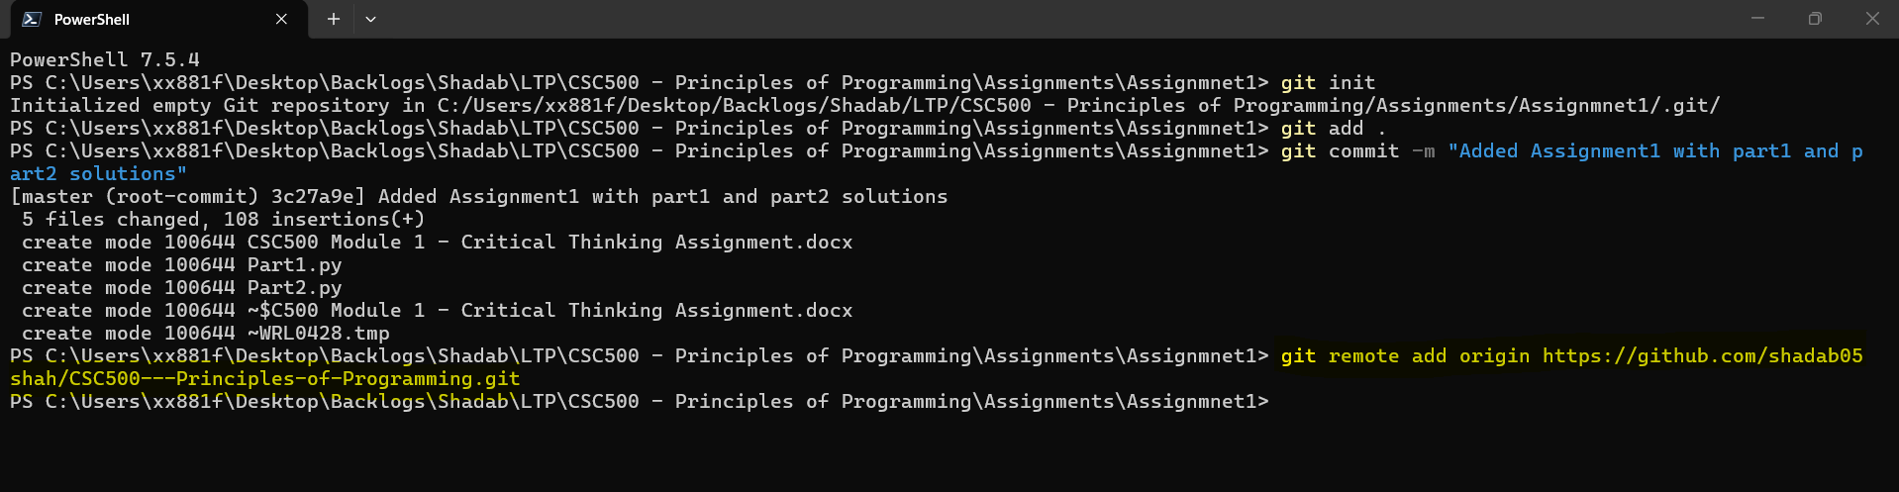

Pushing Changes to Github using
Git branch -M main
Git push -u origin main
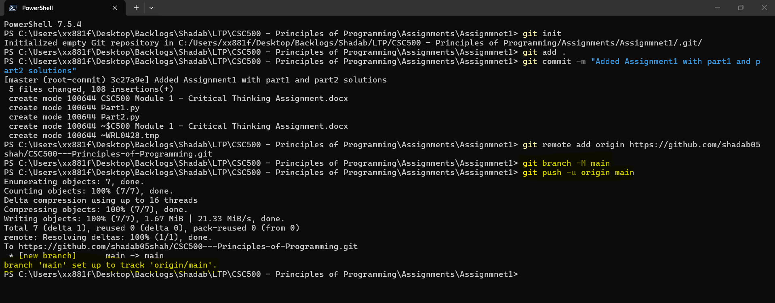

In Git-Hub repo page
